Review

1. Definition
   1. Finite case

* Let be a given set which is finite. S is called Sample space.
* Let (*S*) be the power set(class of subset) of *S*. . Element of power is called an Event.
* Then the probability *P* is defined by



Remark: we use this definition under the assumption that *S* is finite and we have

equiprobability.

* 1. General case
* Let be a given set (it can the set of real number )
* Let (*S*) be the power set(class of subset) of *S.* (*S*) must satisfy the condition of Sigma Algebra. . Element of power is called an Event.
* Then the probability *P* is defined by



such that

* + 
  + There exists with the condition  for (pairwise disjoint), then 

1. Examples
   1. In a bag, there are 5 red balls which are numbered from 1 to 5 and 6 black balls which are numbered for 6 to 11. We select a ball by random. Find the probability that:

* The selected ball is even.
* The selected ball is black.
* The selected ball is black and even.
* The selected ball is black or even.
* The selected ball is even given that it is black (conditional probability).

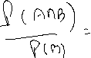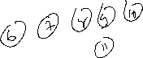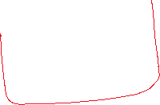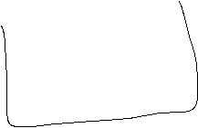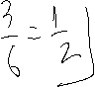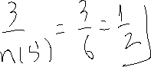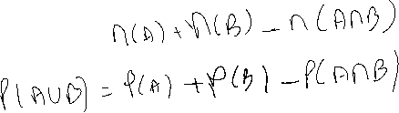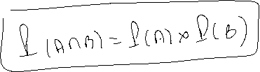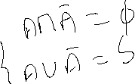

* 1. In a bag, there are 5 red balls and 6 black balls. We select 3 balls randomly. Find the probability that:
* All the balls selected are red.
* All the balls selected are black.
* One of the balls selected is red.
* At least, one of the balls selected is red.

In the following examples, we place ourself in the Random Variable case.

2.3​ Suppose that we toss a coin 3 times (fair coin).

* Write down the sample space.
* Find the probability that Head occur one time.
* Find the probability that Head occur at least one time.
* Suppose that X is the number of Head appears in this experiment. Write down all values of X.
* Calculate the probability of each value of X above and then construct the probability distribution.
* Calculate the Expected Value of X (mean value of X).
* Calculate the Variance of X.

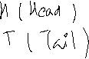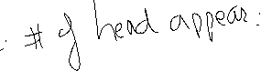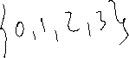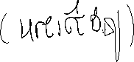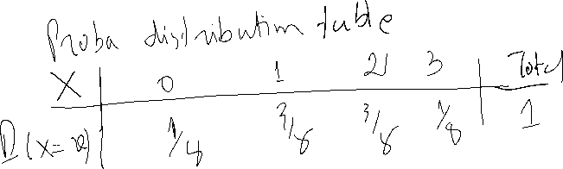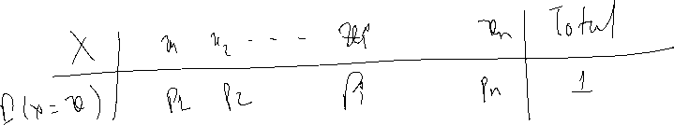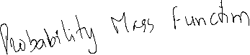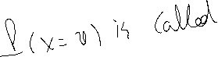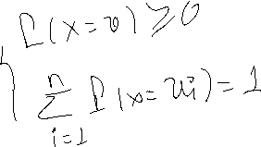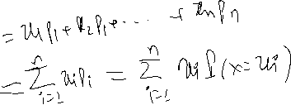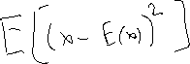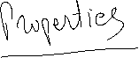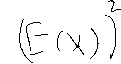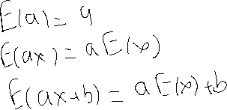

* 1. In a bag, there are 3 red balls and 2 black balls. We select 2 balls randomly.

Suppose that X is the number of black balls selected in this experiment.

* Write down all values of X.
* construct the probability distribution.
* Calculate the Expected Value of X (mean value of X).
* Calculate the Variance of X.
  1. Three balls are randomly chosen from an urn containing 3 white, 3 red, and 5

black balls. Suppose that we win $1 for each white ball selected and lose $1 for each red ball selected. We let *X* denote our total winnings/losings from the experiment.

* Write down all values of X.
* construct the probability distribution.
* Calculate the Expected Value of X (mean value of X).
* Calculate the Variance of X.
  1. CADT organize the entrance exam for the new academic year. The exam is of the multiple-choice question form. For each question, there exists 4 choices and among which one is correct. Condition of the exam is: if a student chooses the right answer, he will get 3 points, otherwise he will lose 1 point.

Question: if a student decides to answer a question, how many points does he expect to gain/lose?

* 1. We place ourself now in the two-digit lottery. Condition of the game is as the

Following. Suppose that a man bets one dollar. If he chooses the right number he will get 70 dollars, otherwise he will lose one dollar.

Question: if a man decides to play this game, how much does he expect to gain/lose?

